Overview
The Kansas Blue Ribbon Panel on Infant Mortality’s interim recommendations for addressing infant mortality include
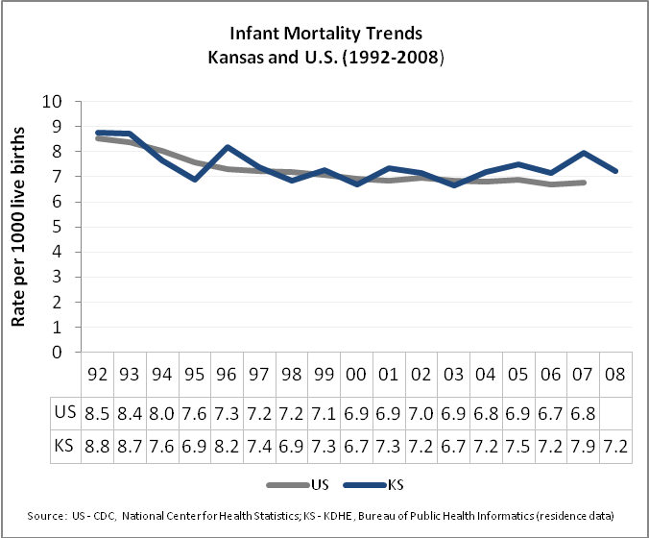
- Expanded surveillance and research;
- Increased public awareness;
- Policies that support increased targeted access to early comprehensive prenatal care and education;
- Reducing risks associated with early death and disability.
The Panel recommends granting statutory authority to the Kansas Department of Health and Environment to use vital records data for surveillance using CDC-recommended programs including PRAMS (Pregnancy Risk Assessment Monitoring System) and FIMR (Fetal and Infant Mortality Review). The Panel recommends reducing health risks during the pre-pregnancy, pregnancy, and early infant life by reducing tobacco exposure through tobacco-prevention legislation, and legislation that promotes healthy behaviors and increased access to care and services.
Background and Process
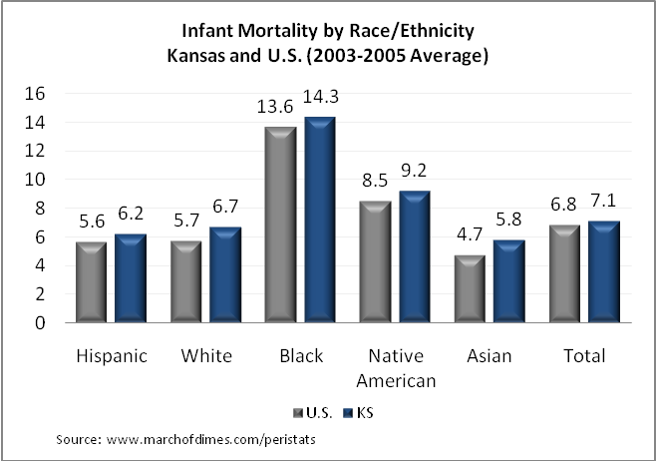
The Kansas Blue Ribbon Panel on Infant Mortality was formed in June 2009 and was charged to review the infant mortality problem in Kansas and deliver recommendations to the Secretary of Kansas Department of Health and Environment through the Governor’s Child Health Advisory Committee. The Panel consists of 22 members with a broad range of expertise related to maternal, infant, and child health.
In the past seven months, the Panel has met six times and has listened to out-of-state experts, in-state experts, representatives of successful programs and promising practices. It has also reviewed analyses of Kansas and national data trends, commissioned a best practices literature review, and discussed the viability and potential impact of possible solutions for Kansas.
Infant mortality is a complex issue with many contributing factors. The Panel will continue to meet and research short- and long-term recommendations in the coming months; however, this interim report contains the Panel’s initial recommendations.
Overview of Problem
Three decades ago, Kansas’ infant mortality rate compared favorably to that of other states. In recent years, the Kansas infant mortality rate has stagnated while the US rate continued to decline. In 2007, Kansas’ rate of 7.9 infant

deaths per 1,000 live births was nearly 20% higher than the national rate of 6.8 per 1,000 live births.
Furthermore, while many states have made progress closing the gap between the infant mortality rates of black infants and white infants, Kansas has not. Infant mortality among black infants is more than double that of the rate among white infants. Black babies represent 7% of births and 17% of deaths. Among other states, Kansas ranks 2nd highest for black infant mortality (2006). When comparing by race and ethnicity, Kansas rates are higher than U.S. for all racial and ethnic groups.
Leading causes of infant deaths in Kansas are congenital anomalies (20%), pre-term birth/low birth weight (18%), Sudden Infant Death Syndrome (SIDS) (15%), and maternal complications of pregnancy (10%) (2007). Two-thirds of infant deaths are neonatal (i.e., within the first twenty-eight days of life) while one-third are post-neonatal (i.e., more than 28 days through one year old).
Interim Recommendations
Based on data reviewed so far, the Kansas Blue Ribbon Panel on Infant Mortality presents the following interim recommendations in four areas.
- Improved Data and Surveillance and Expanded Research
  - Support public health surveillance of maternal and child health issues, including legislation to improve Kansas’ ability to gather data needed to implement community-level programs and access additional federal funding to address infant mortality issues, including the PRAMS (Pregnancy Risk Assessment Monitoring System) and FIMR (Fetal and Infant Mortality Review) programs.
  - Endorse partnership between Child Death Review Board and the Kansas Department of Health and Environment to enhance review of neonatal and infant deaths.
  - Explore alternative data collection system to promote focused, readily-accessible, usable data for research, monitoring, and measurement of quality.
  - Implement a statewide surveillance system for perinatal care.
  - Conduct a State Perinatal Periods of Risk (PPOR) assessment regularly to help target resources for the biggest impact.
  - Continue to research other successful programs and evidence-based practices, both nationally and internationally.
- Increased Public Awareness and Education
  - Develop a public awareness campaign on infant mortality.
  - Support SIDS Network of Kansas as the anchor of a statewide initiative involving all professional and community-based organizations to promote safe sleep practices.
  - Promote healthy lifestyles among women of childbearing age.
  - Promote healthy behaviors among teens, including the effects of unhealthy behaviors on future child-bearing.
- Increased Access to Care and Services
  - Support practices and policies that improve access to early, targeted, and comprehensive prenatal care and education. Specific examples include expedited Medicaid application for pregnant women, comprehensive prenatal care coordination for targeted high-risk groups, and adequate insurance reimbursement for options such as group visits and centering care.
  - Apply for and implement Medicaid 1115 Waiver for increased access to pregnancy planning services, resulting in healthier pregnancy outcomes.
  - Improve access to genetic counseling services in the state.

- Implementation of Programs and Interventions
  - Support development of the State Genetics Plan to develop state capacity to address causes of early death and lifelong disability.
  - Support tobacco-prevention legislation.
  - Support perinatal health collaborative efforts, including the Maternal and Child Health Council and perinatal casualty studies.
  - Create a statewide perinatal-neonatal collaborative to monitor quality and promote quality improvement.
  - Support Kansas communities in addressing their own infant mortality problems through model programs like FIMR and Healthy Start.
The Kansas Blue Ribbon Panel on Infant Mortality membership included individuals from the following organizations:
- Child Death Review Board
- Department of Neonatology, Wesley Medical Center
- Governor’s Child Health Advisory Committee
- Healthy Babies, Inc., Sedgwick County Health Department
- Kansas Action for Children
- Kansas African American Affairs Commission
- Kansas Association of Child Care Resource and Referral Agencies
- Kansas City University of Medicine and Biosciences
- Kansas Chapter of the American Academy of Pediatrics
- Kansas Department of Health and Environment (KDHE)
- KDHE Center for Health Disparities
- Kansas Head Start Association
- Kansas Health Institute
- Kansas Hispanic and Latino American Affairs Commission
- March of Dimes Greater Kansas Chapter
- Maternal Fetal Medicine, Stormont-Vail Regional Health Center
- Mother and Child Health Coalition of Greater Kansas City
- SIDS Network of Kansas, Inc.
- University of Kansas
- University of Kansas Medical Center

